Morse code Translator

Objective:

Using the input of a user, create a Morse code translator from word to code and from code to word.

Complexity level:

* Hard

Business Scenario:

* John Doe is in the military for X country trying to optimize a program that translates Morse code and sends Morse messages.

Data set:

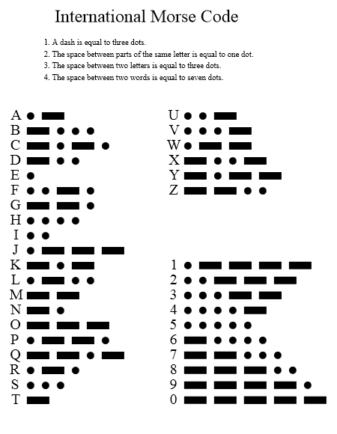

Problem Statement:

1. Write a Morse code translator that translates 3 and 4 letter words to Morse code (o’s for dots, -’s for dashes, printing one letter per line, using the above given data set.
2. Write a second algorithm, which takes in dots (o’s) and dashes (-’s) (each letter being its own user input), and concatenates the letters into one word after the user types “END” .

Expectation Outcome:

This creates a translator for Morse code, and will help the student practice user input, and will create a complex problem for practice of input, string concatenation, and will create a useful tool.

Tools:

* Open office for designing the flow chart.

Reference URL:

1. ["International Morse code Recommendation ITU-R M.1677-1"](http://www.itu.int/rec/R-REC-M.1677-1-200910-I/). itu.int. International Telecommunication Union. October 2009. Retrieved 23 December 2011.
2. L. Peter Carron, "Morse code: The Essential Language", Radio amateur's library, issue 69, American Radio Relay League, 1986 [ISBN 0-87259-035-6](https://en.wikipedia.org/wiki/Special:BookSources/0872590356) .
3. ["An obituary for Morse code"](http://www.highbeam.com/doc/1G1-53668116.html), The Economist, January 23, 1999.